Linux Commands PART II

1. **Elevate your user access to root; *sudo su**

First I faced issues with this and probally I have created it

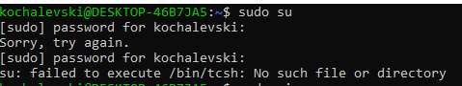

I’ve fix it with thru the following steps:



And changed:

root:x:0:0:root:/root:/bin/chsh into: root:x:0:0:root:/root:/bin/bash

So I am able to use sudo su now, here is the loging:

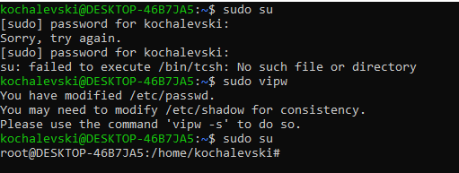

1. **Add a new user to your Linux OS and set a password for it; *sudo adduser username**

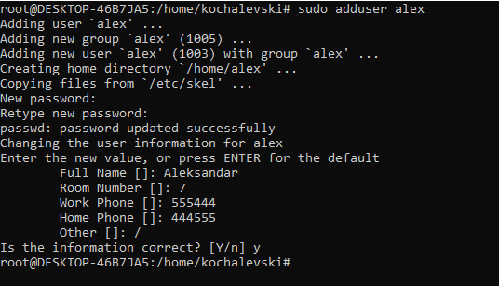

**3. Test if you can log in using that user; *su – username**



**4. Using grep command check if the user is created; *grep username /etc/passwd**



**5. grep the UID of each user; *cut -d: -f1,3 /etc/passwd**

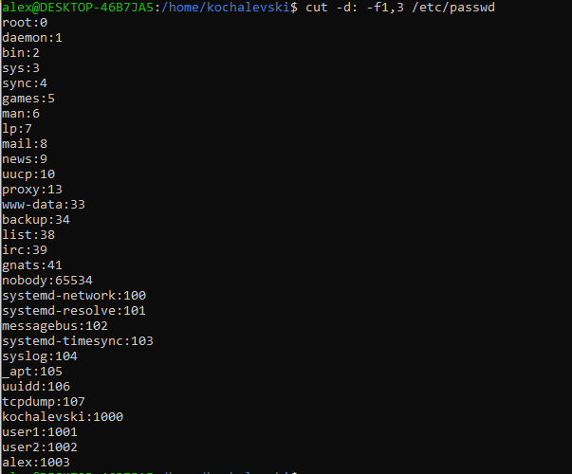

**6. Find out the GID of the created user; *id -g username**



**7. Change the password of the user and force it to change the pass on his next login; *sudo passwd -e username**

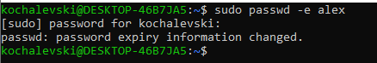

**8. Add a new user and set an expiration date for it, with a five-day warning period;**

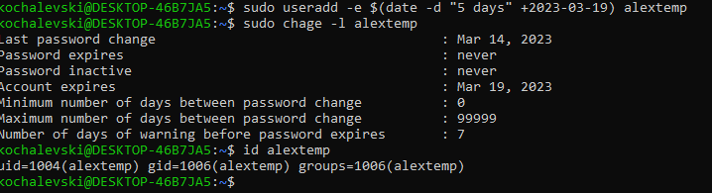

**9. Create a new group; *sudo groupadd groupname**



**10. Assign the two new users to that group; * sudo usermod -a -G groupname username1, username2**

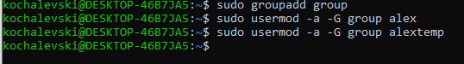

**11. Lock one of the user accounts; * sudo passwd -l username**



**12. Change the shell of one user to tcsh; *sudo chsh -s /bin/bash username**



**13. Make sure your home directory has “execute” access enabled for group and other. *chmod +x ~**

**14. Change to your home directory, and create a directory called labs; *cd ~,* mkdir labs**

**15. Create an empty file in labs directory *touch labs/emptyfile**

**16. Change permissions of file to rwx-rwx-rwx *chmod 777 emptyfile**

**17. List the file. What color is the file? *ls (green)**

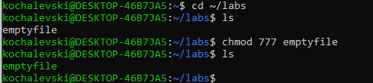

**18. Change the permissions back to rx-rw-rw*chmode 566 file.txt**



**19. Check what owners does the file have.*ls -l file.txt**



**20. Change the user ownership of the file to another user; *sudo chown newuser file.txt**

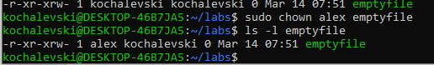

**21. Create a group called group1 and assign two users to the group;**

**\*sudo groupadd group2**

**\*sudo usermod -a -G group2 username1**

**\*sudo usermod -a -G group2 username2**

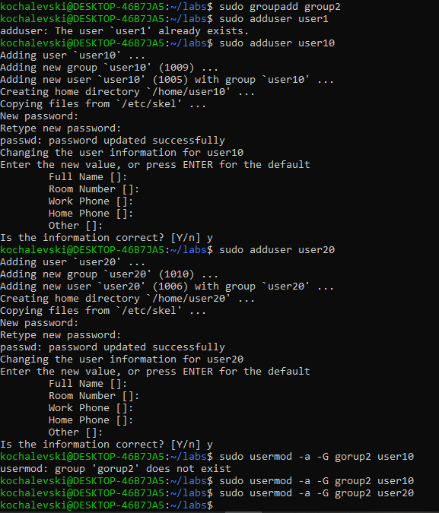

**22. Create a file called group1.txt and redirect below input into the file:**

**“This is our group test file”. *echo “text” > file.txt**



**23. Change the group of the file to one of your users; *sudo chgrp user file.txt**



**24. Give members of the group group1 read/write access to this file?\*** **sudo chmod g+rw group2.txt**

